**WEEK 1 ASSIGNMENT**

|  |  |  |
| --- | --- | --- |
| NAME:JAYANTH R | REG NO: 20BEC1176 | INTERN DOMAIN: IOT |

**TASK:**

In Wokwi simulator, if the distance is less than 100 cms for ultrasonic sensor, glow a LED.

**WOKWI LINK:**

https://wokwi.com/projects/365426094170471425

**Circuit Diagram:**

**Code:**

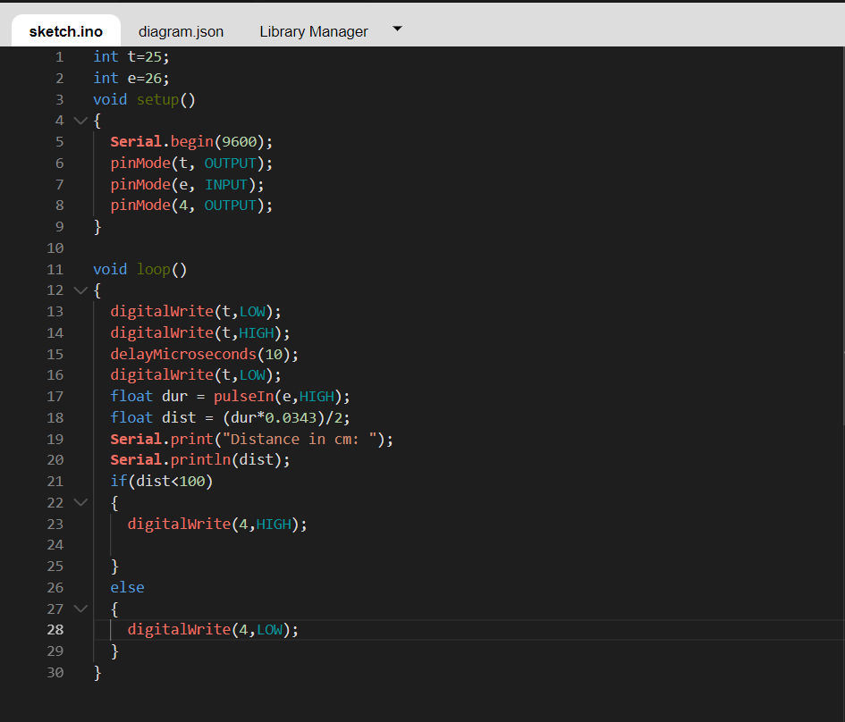

**OUTPUTS:**

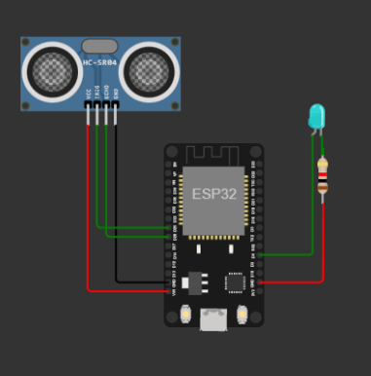

When distance of ultrasonic sensor is greater than 100cm:

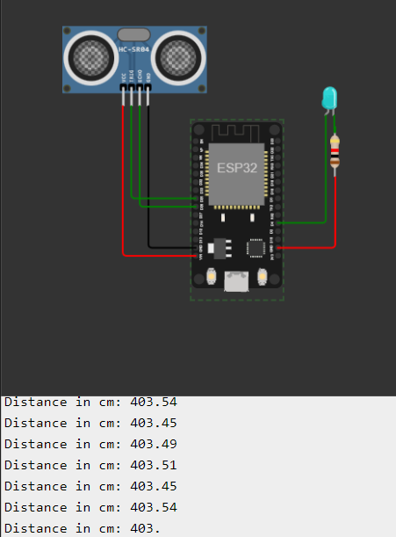

When distance of ultrasonic sensor is less than 100cm:

**RESULT:** Given task was carried out successfully.